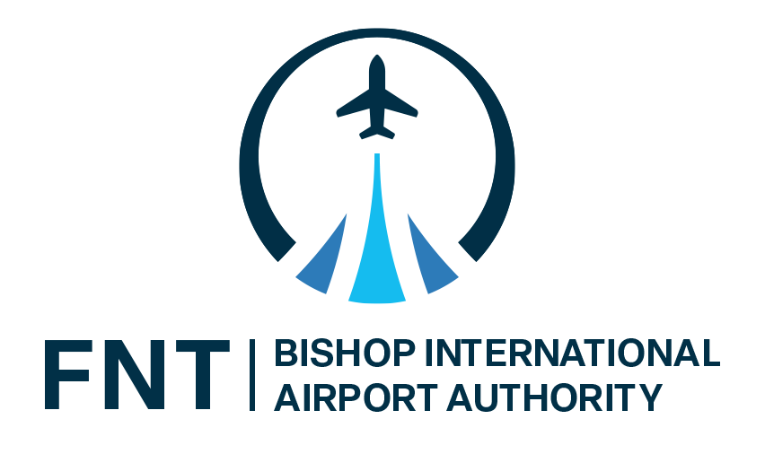
Winfield L. Cooper III
Chairperson
Loyst Fletcher, Jr.
Vice-Chairperson
Mark Yonan
Secretary
Karyn L. Miller
Treasurer

Clyde D. Edwards
Erwin F. Meiers Iii
Valaria Conerly Moon
John A. Tosto
George D. Wilkinson

Nino Sapone, A.A.E.
Chief Executive Officer

P U B L I C N O T I C E

Pursuant to Act 267 of the Public Acts of 1976, notice is hereby given that there will be a regular meeting of the Airport Authority Board on Tuesday, June 2, 2026, at 11:30 AM in the Sharp Conference Room at Bishop International Airport.

The purpose of the meeting is general Authority Business.

As the State of Emergency for the County of Genesee as declared by the Genesee County Board of Commissioners has been lifted, pursuant to Section 3(a) of the Open Meeting Act, members are required to meet in-person, unless unable to do so due to military duty.

Bishop Airport will furnish reasonable auxiliary aids and services to individuals that require them upon 48 hours- notice.

Those needing assistance should write or call Kathy Bradburn, Executive Assistant, at the address or number below or by calling the Michigan Relay Center at 711.

Para recibir una traducción de este aviso público, comuníquese con el Coordinador del Título VI de la Autoridad del Aeropuerto Internacional Bishop en cyeates@bishopairport.org

Dated this 29th day of May 2026

Kathy Bradburn
Kathy Bradburn
Executive Assistant

